# Lab 8

**Experiment: Basic Networking Setup**

Objective: To understand the fundamentals of networking by setting up a local area network (LAN) using routers, switches, and computers. The goal is to configure IP addresses, subnet masks, and gateways, and to test connectivity between devices.

Materials Needed Hardware:

1. 1 Router
2. 1 or more Switches
3. 2 or more Computers (or laptops)
4. Ethernet cables
5. Power source for devices

Software:

1. Operating system with network configuration capability (Windows, Linux, etc.)
2. 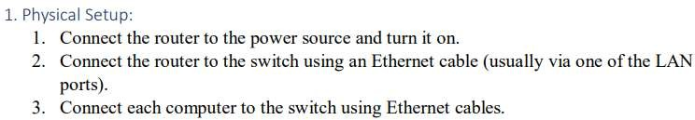Basic command-line tools (Command Prompt for Windows, Terminal for Linux) Procedure

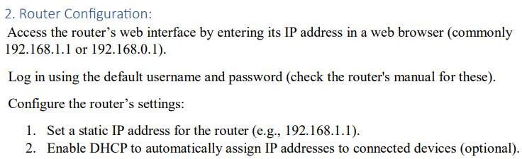



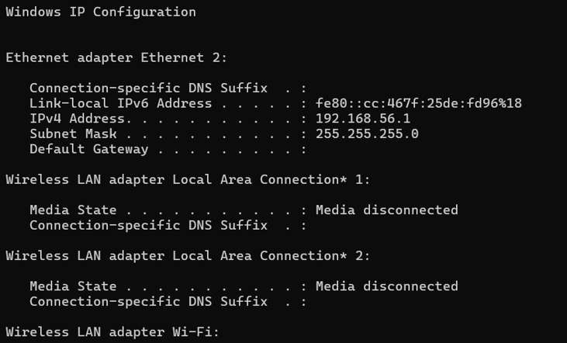

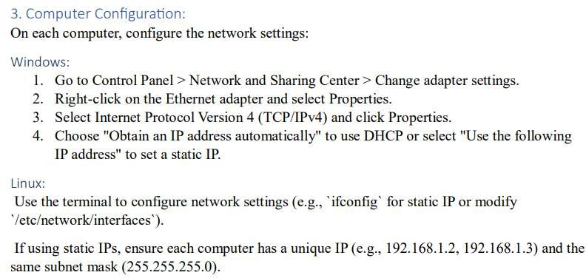

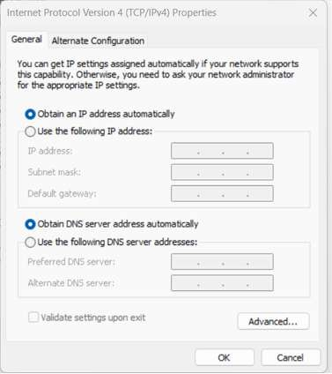

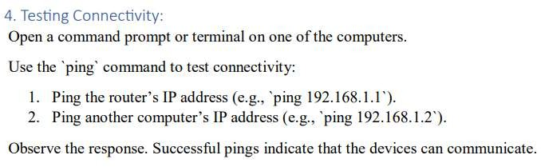

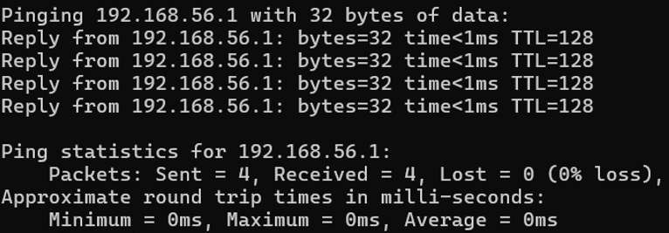

# Experiment: File transferring within a network

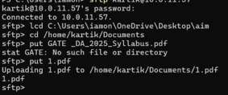Transferring files between computers on the same network using the terminal can be accomplished with various tools and protocols. Here is example using Sftp.